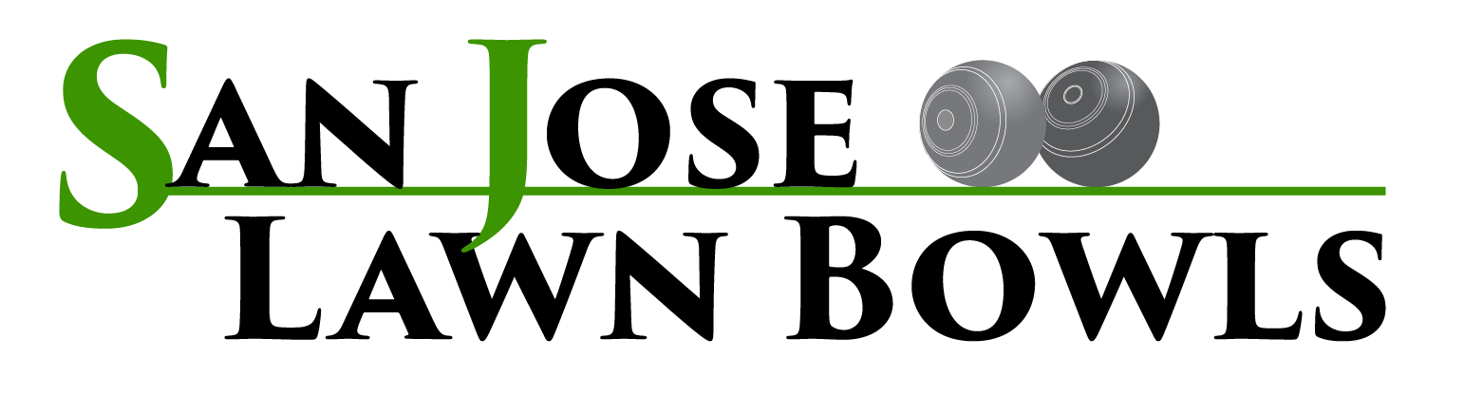
SAN JOSE LAWN BOWLS CLUB - MEMBERSHIP APPLICATION

To the Board of San Jose Lawn Bowls Club:

I hereby make application for membership in the San Jose Lawn Bowls Club (SJLBC). If I am accepted as a member, I shall abide by the SJLBC Constitution, By-Laws, and Standing Rules. I agree to hold the City of San Jose, SJLBC and its Board harmless of any claims and suits arising out of, or caused by, my participation in lawn bowling club activities sponsored by, or in association with the SJLBC. I further recognize that there may be inherent risks associated with such participation in lawn bowling activities, and I personally accept responsibility for those risks.

Name: _________________________________________________ Date:___________

Street: __________________________________________City: ___________________

State: _____Zip Code: _________E-mail Address: ______________________________

Phone: Home: __________________________Mobile: __________________________

SJLBC Member Sponsor: ___________________________________________________

Preferred Method(s) of Contact: ____Phone (home/mobile), ____email, ___direct mail

SJLBC maintains a Confidential Member Roster of the above information for Club, PIMD and Bowls USA records. A separate listing of selected member contact information will be available to facilitate member/member communication.

I am applying for:

_____Primary Membership in SJLBC, Bowls USA, and PIMD
_____Primary Membership in SJLBC and PIMD
_____Dual Membership in SJLBC (Primary Club: ___________________________)

_____Associate (Non-Bowling) Membership in SJLBC

If my application is approved, I agree to pay all dues and fees as specified in the each year’s dues notice as posted.

Signature: ________________________________________Date: __________________

sjlbc.org sanjoselawnbowls@gmail.com FB: San Jose Lawn Bowls Club
SAN JOSE LAWN BOWLS CLUB - MEMBERSHIP APPLICATION

________________________________________________________________________
________________________________________________________________________

Applicant Name: _________________________________________________________

Level of Membership:

_____Primary Membership in SJLBC, Bowls USA, and PIMD
_____Primary Membership in SJLBC and PIMD
_____Dual Membership in SJLBC (Primary Club: ___________________________)

_____Associate (Non-Bowling) Membership

Approved for bowling in games by Coach: ___________________________ Date: ______

Approved for membership by the SJLBC Board: _____ Date: _______

President: ____________________________________________ Date: ________

Secretary: ____________________________________________ Date: ________

